所有道具

**武器箱子**

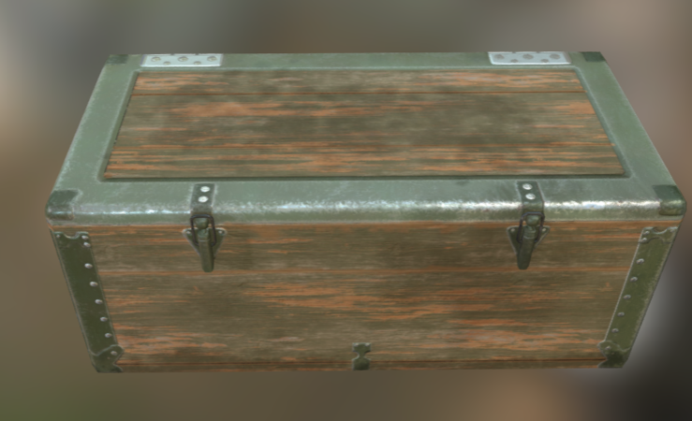

链接：[Weapon Box | 3D 道具 | Unity Asset Store](https://assetstore.unity.com/packages/3d/props/weapon-box-63084)

操作：左键打开，在场景中将被摧毁

用途：获得该阶段的随机武器

**道具箱子**



链接：[Potions, Coin And Box of Pandora Pack | 3D 道具 | Unity Asset Store](https://assetstore.unity.com/packages/3d/props/potions-coin-and-box-of-pandora-pack-71778#content)

操作：左键打开，在场景中将被摧毁

用途：获得该阶段的随机道具

**生命药水**

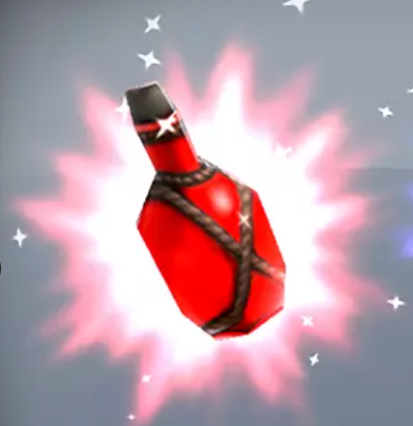

链接：[Potions, Coin And Box of Pandora Pack | 3D 道具 | Unity Asset Store](https://assetstore.unity.com/packages/3d/props/potions-coin-and-box-of-pandora-pack-71778" \l "content)

操作：左键消耗，数量-1，

用途：回复生命

**加速药水**

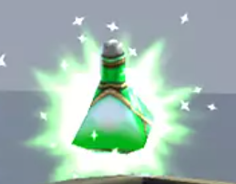

链接：[Potions, Coin And Box of Pandora Pack | 3D 道具 | Unity Asset Store](https://assetstore.unity.com/packages/3d/props/potions-coin-and-box-of-pandora-pack-71778#content)

操作：左键消耗，数量-1

用途：增加移动速度

**跳跃药水**

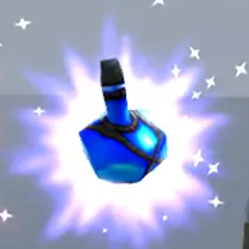

链接：[Potions, Coin And Box of Pandora Pack | 3D 道具 | Unity Asset Store](https://assetstore.unity.com/packages/3d/props/potions-coin-and-box-of-pandora-pack-71778#content)

操作：左键消耗，数量-1

用途：增加跳跃高度

**大门钥匙1 && 大门钥匙2**

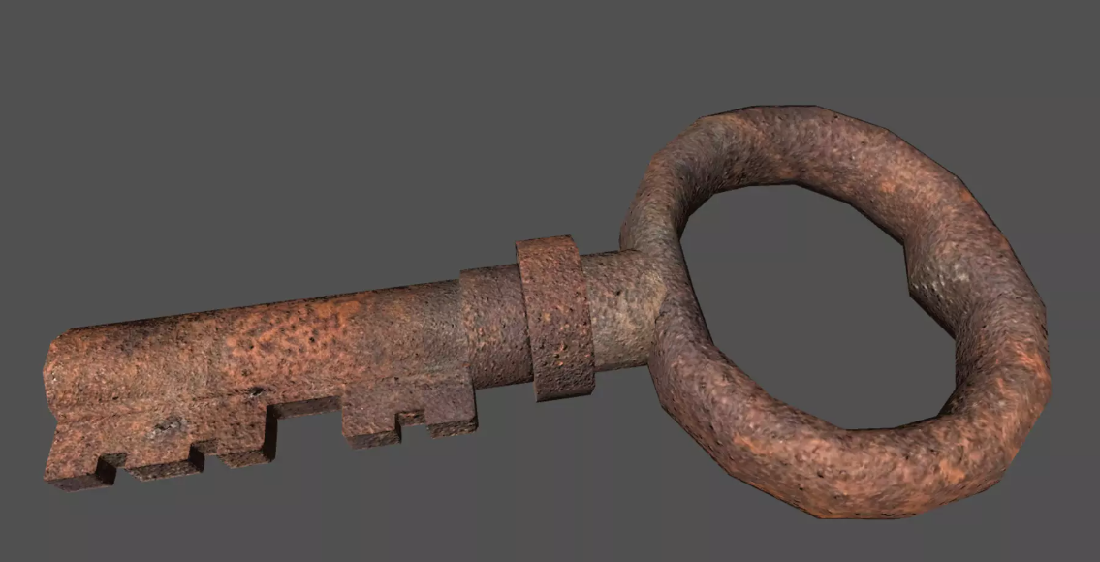

链接：[Rust Key | 3D 道具 | Unity Asset Store](https://assetstore.unity.com/packages/3d/props/rust-key-167590" \l "reviews)

操作：左键消耗，数量-1

用途：开启第一关大门的钥匙，可以在第一关箱子里/守卫身上找到

**计时器**

操作：左键消耗，数量-1

用途：增加30秒剩余时间